REVISION 1 FOR THE THIRD TEST- ENGLISH 7

A. LEXICAL LANGUAGE
I. Choose the word that has the underlined part is pronounced differently from the others.
1. A. healthy B. ahead C. bread D. seatbelt
2. A. played B. closed C. filled D. needed
II. Choose the word whose main stress is placed differently from the others.
1. A. traffic B. agree C. noisy D. student
III. Choose the best answer by circling A, B, C or D.
1. Mai used to ________ morning exercise when she was a girl.
A. did B. does C. doing D. do
2. Traffic accidents can be prevented if everyone __________ the rules.
A. remember B. obey C. go after D. take care of
3. People should look right and left when they go ________the road.
A. down B. across C. up D. along
4. The play was so boring. ________, Hoa saw it from beginning to end.
A. Therefore B. Despite C. However D. Although
5. ____________ being frightened by the images, Lan still liked the film so much.
A. In spite B. Despite C. Although D. Nevertheless
6. ____________ is La Tomatina celebrated? – Every August.
A. Where B. Why C. When D. Which
7. The signal says “Left turn only”
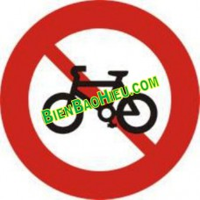
A B C D
8. The signal says “Traffics lights”.
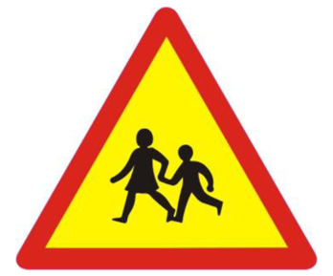
A B C D

IV. Use the correct form of the words in brackets.
1. Nam liked the ____________________ of that actor. (PERFORM)
2. This history book is _________________I get more interested in history. (INTEREST)
B. READING
I. Read and match the types of films with their definitions.
Types of film | Definitions
1. Science fiction | A. a. A film that tries to make audiences laugh.
2. Romantic comedy | b. A film that features cartoon characters.
3. Animation | c. A film that is set in the future, often featuring science
4. Comedy | d. A film which combines comedy with a love story
5. Documentary | e. A film that shows real life events or stories.
II. Read the passage carefully then answer the questions.
People of ethnic minorities in Phu Yen celebrate Hoi Mua Festival every March. It is held to thank the Rice God for the crop, and to pray for better crops in the future. Families also worship their ancestors and parents on this occasion. Villagers voluntarily contribute money and other things to celebrate the festival.
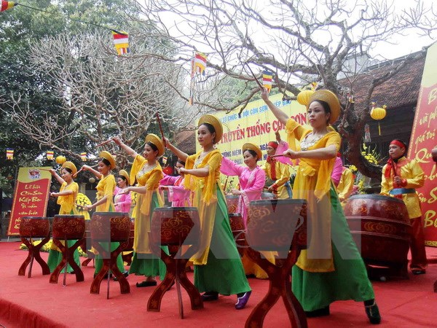
In this festival monks are invited to preach. People play drums, sing songs and dance. They also drink rice wine through a long thin bamboo tube. There are some other activities such as cultural shows, buffalo races, and traditional games. The festive atmosphere is felt around all the villages.
Questions:
1. Who in Phu Yen celebrate Hoi Mua Festival every March?
……………………………………………………………………………………………..
2. When is it held?
……………………………………………………………………………………………..
3. What do villagers voluntarily contribute to celebrate the festival?
……………………………………………………………………………………………..
4. Are monks invited play drums, sing songs and dance?
……………………………………………………………………………………………..
5. Where is the festive atmosphere felt?
……………………………………………………………………………………………..
C. WRITING

1. Rewrite these sentences, so that their meaning stays the same, using the beginning given for each.
1. What is the distance between Quang Ngai and Ho Chi Minh city?
=> How…………………………………………………………….?
2. I often walked to school when I was a student.
=> I used……………………………………………………………
3. Although Tom was a poor student, he studied very well.
=> In spite of …………………………………………………………………………
4. Although the weather was bad, she went to school on time.
=> Despite
II. Write about from 80→ 100 words about the film which you saw
.....................................................................................................…………
………………………............................................................................................................………………………............................................................................................................…………

Keys:
A. LISTEN:
I. Listen to a music festival and tick (√) true ( T ) or false (F) (1.2pts)
 |  | T | F
1 | The Isle of Wight is the most well-known festival in the world |  | √
2 | About 60,000 people attended the festival last year | √
3 | Nick and his family stayed at a hotel near the campsite |  | √
4 | Jon Bon Jovi is Nick’s favourite singer |  | √
II. Listen to a music festival again and then answer the questions (1.2 pts)
1. It takes place every June.
2. It is a music band.
3. He interested the audience with his song.
4. They enjoyed a mix of good music form around the world.
B. USE OF ENGLISH (2.2 pts)
I. Choose the word that has the underlined part is pronounced differently from the others.(0.4pt)
1.D
2.D
II. Choose the word whose main stress is placed differently from the others. (0.2 pt)
1.B
III. Choose the best answer by circling A, B, C or D: (1.2pts)
1. Mai used to ________ morning exercise when she was a girl.
A. did B. does C. doing D. do
2. Traffic accidents can be prevented if everyone __________ the rules.
A. remember B. obey C. go after D. take care of
3. People should look right and left when they go________the road.
A. down B. across C. up D. along
4. The play was so boring. ________, Hoa saw it from beginning to end.
A. Therefore B. Despite C. However D. Although
5. ____________ being frightened by the images, Lan still liked the film so much.
A. In spite B. Despite C. Although D. Nevertheless
6. ____________ is La Tomatina celebrated? – Every August.
A. Where B. Why C. When D. Which
7. The signal says “ left turn only” → C
A B C D
8. The signal says “ traffics lights” → C
A B C D

IV. Use the correct form of the words in brackets (0.4 pt)
1. Nam liked the … PERFORMANCE.. of that actor. (PERFORM) →(PERFORMANCE)
2. This history book is … INTERESTING …I get more interested in history. (INTEREST)
C. READ (2.5 pts)
I. Read and match the types of films with their definitions. (1 pt)
Types of film | Definitions.
- 1.science fiction | A. a. film that tries to make audiences laugh.
- 2. romantic comedy | b. A film that features cartoon characters.
- 3. animation | c. A film that is set in the future, often featuring science
- 4. comedy | d. A film which combines comedy with a love story
- 5 documentary | e. A film that shows real life events or stories.

1c | 2d | 3b | 4a | 5e

II. Read the passage carefully then answer the questions. (1.5 pts)
1. People of ethnic minorities in Phu Yen celebrate Hoi Mua Festival every March.
2. It is held every March
3. Villagers voluntarily contribute money and other things to celebrate the festival.
4. No, they aren’t.
5. The festive atmosphere is felt around all the villages.
D. Write (2,5)

1-Rewrite these sentences, so that their meaning stays the same, using the beginning given for each.(1 pt)
1. What is the distance between Quang Ngai and HCM city?
=> How far is it from Quang Ngai to HCM city?
2. I often walked to school when I was a student.
=> I used to walk to school when I was a student.
3. Although Tom was a poor student, he studied very well.
=> In spite of being a poor student, Tom studied very well
4. Although the weather was bad, she went to school on time.
=> Despite the bad weather, she went to school on time
II. Write about from 80→ 100 words about the festival which you attended (1.5)
Writing right and enough above requests.

 |  | Nhận biết |  | Thông hiểu |  | Vận dung |  |  |  | Cộng
 | Nội dung |  |  |  |  | Cấp độ thấp |  | Cấp độ cao
 | Nội dung | KQ | TL | KQ | TL | KQ | TL | KQ | TL
A  Listening | - Review vocabulary: vocabulary of unit 7,8 and 9 the items related to traffic, films, festival around the world. |  |  | 4  0.3 | 4  0.3 |  |  |  |  | 8  2.4
B.  Reading | -Match the types of film with their definitions .  -Ss understand the passages and answer the questions. | 5  0.2 |  |  | 5  0,3 |  |  |  |  | 10  2,5
C.  Use of English | -The sounds / e / and / ɪ/, sounds /e/, /ei/ and conjunctions:  Stress on 1st syllable,  Stress on 2nd syllable, Pronounce correctly the –ed ending in verbs.  Although, despite/ in spite of, however, and nevertheless.  -Use “it” for distances, -Use “ used to” to talk about past habit or state.  -The meaning and how to use –ed and –ing adjectives. | 11  0,2 |  |  |  |  | 2  0.2 |  |  | 13  2.6
D.  Writing | I. Rewrite the following sentences without changing the meaning: (1.pt)  Write about from 80→ 100 words about  The usage of “How” to ask about means of transport. |  |  |  |  |  | 5  0.3 |  | 5  0.2 | 10  2.5
Total |  | 16  3.2 |  | 4  1.2 | 9  2.7 |  | 7  1.9 |  | 5  1 | 41  10
% |  | 32 % |  | 39% |  | 19 % |  | 10% |  | 100%
% Trắc nghiệm KQ |  | 32.% |  | 12 % |  |  |  |  |  | 44 %
% Tự luận |  |  |  |  | 27 % |  | 19% |  | 10% | 56 %

-The sounds / e / and / ɪ/, conjunctions: Although, despite/ in spite of, however, and nevertheless

Duc Thanh Junior High School  Class: 7  Name: | CHECK 45’ (3)  Subject: English | Marks:
A. LISTEN:
I. Listen to a music festival and tick (√) true ( T ) or false (F) (1.2pts)
 |  | T | F
1 | The Isle of Wight is the most well-known festival in the world
2 | About 60,000 people attended the festival last year
3 | Nick and his family stayed at a hotel near the campsite
4 | Jon Bon Jovi is Nick’s favourite singer
II. Listen to a music festival again and then answer the questions (1.2 pts)
1. When does the festival take place? ……………………………………………………….
2. What is The Killer? …………………………………………………….
3. How did Jon Bon Jovi interest the audience? ………………………………………
4. What did they do there? …………………………………………………….
B. USE OF ENGLISH (2.2 pts)
I. Choose the word that has the underlined part is pronounced differently from the others.(0.4pt)
1. A. healthy B. ahead C. bread D. seatbelt
2. A. played B. closed C. filled D. needed
II. Choose the word whose main stress is placed differently from the others. (0.2 pt)
1. A. traffic B. agree C. noisy D. student
III. Choose the best answer by circling A, B, C or D: (1.2pts)
1. Mai used to ________ morning exercise when she was a girl.
A. did B. does C. doing D. do
2. Traffic accidents can be prevented if everyone __________ the rules.
A. remember B. obey C. go after D. take care of
3. People should look right and left when they go________the road.
A. down B. across C. up D. along
4. The play was so boring. ________, Hoa saw it from beginning to end.
A. Therefore B. Despite C. However D. Although
5. ____________ being frightened by the images, Lan still liked the film so much.
A. In spite B. Despite C. Although D. Nevertheless
6. ____________ is La Tomatina celebrated? – Every August.
A. Where B. Why C. When D. Which
7. The signal says “ left turn only”
A B C D
8. The signal says “ traffics lights”
A B C D

IV. Use the correct form of the words in brackets (0.4 pt)
1. Nam liked the ____________ of that actor. (PERFORM)
2. This history book is ……………. I get more interested in history. (INTEREST)
C. READ (2.5 pts)
I. Read and match the types of films with their definitions. (1 pt)
Types of film |  | Definitions.
- 1.science fiction |  | A. a. film that tries to make audiences laugh.
- 2. romantic comedy |  | b. A film that features cartoon characters.
- 3. animation |  | c. A film that is set in the future, often featuring science
- 4. comedy |  | d. A film which combines comedy with a love story
- 5 documentary |  | e. A film that shows real life events or stories.
1 | 2 |  | 3 | 4 | 5
II. Read the passage carefully then answer the questions. (1.5 pts)
People of ethnic minorities in Phu Yen celebrate Hoi Mua Festival
every March. It is held to thank the Rice God for the crop, and to pray for better crops in the future. Families also worship their ancestors and parents on this occasion. Villagers voluntarily contribute money and other things to celebrate the festival.
In this festival monks are invited to preach. People play drums, sing songs and dance. They also drink rice wine through a long thin bamboo tube. There are some other activities such as cultural shows, buffalo races, and traditional games. The festive atmosphere is felt around all the villages.
Questions:
1. Who in Phu Yen celebrate Hoi Mua Festival every March?
……………………………………………………………………………………………………..
2. When is it held?
……………………………………………………………………………………………………..
3. What do villagers voluntarily contribute to celebrate the festival? ……………………………………………………………………………………………………..
4. Are monks invited play drums, sing songs and dance? ……………………………………………………………………………………………………..
5. Where is the festive atmosphere felt? ……………………………………………………………………………………………………..
D. Write (2,5)

1-Rewrite these sentences, so that their meaning stays the same, using the beginning given for each.(1 pt)
1. What is the distance between Quang Ngai and HCM city?
=> How…………………………………………………………….?
2. I often walked to school when I was a student.
=> I used……………………………………………………………
3. Although Tom was a poor student, he studied very well.
=> In spite of …………………………………………………………
4. Although the weather was bad, she went to school on time.
=> Despite ……………………………………………………….
II. Write about from 80→ 100 words about the festival which you attended (1.5)
………………………............................................................................................................……………………………............................................................................................................………………………....................................... ....................................………………………............................................................................................................…
………………………............................................................................................................……………………….......
…............................................................................................................………………………....................................... ....................................………………………............................................................................................................…
………………………............................................................................................................……………………….......
………………………............................................................................................................……………………………............................................................................................................………………………....................................... ....................................………………………............................................................................................................…
………………………............................................................................................................……………………….......

